Client_Text_UI

This module provides a text interface to the client interface which in turn provides an interface to the server. The program takes requests from the user and executes the command , returning the data to the user in a more managable form. The user is allowed to enter values for each command and passes the information to the server.

HCI
The general interface system follows the pattern:
Display command list/ menu options
Enter Command number
For each data value needed:
Enter the relevant data value

Display response:
Sucess
Message
If data is present Then : Display data in pretty table using message

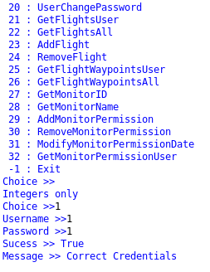

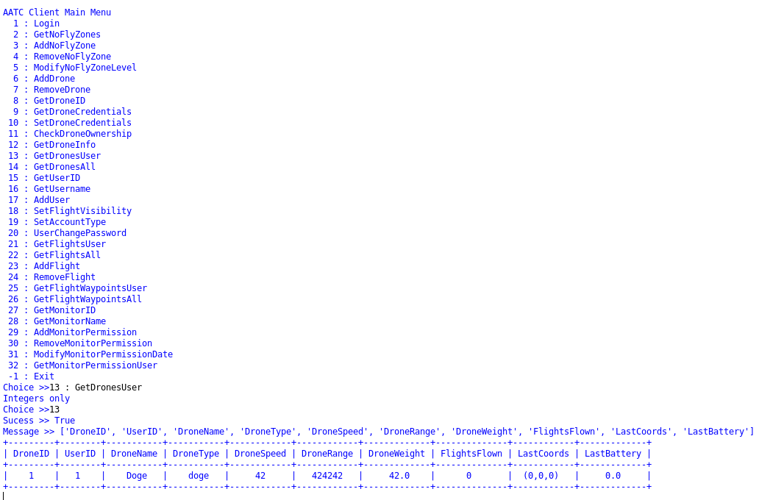

Import

The program required 3 other modules, pretty table in order to display the results of a request, AATC_Client for the interface to the server and ast to convert strings to other literals.

MenuOptions
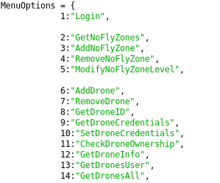
Menu options is a dictionary containing an integer key and string result, matching a single integer the user enters with a string command to be passed on. This allows looking up of the commands in O(1) time as well as resulting in the user not having to enter the entire command each time.

UserTextUI
General
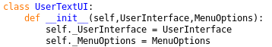
This class is the main class of this module. The class manages the input of the user and maps each input to a command which must be output. It keeps the UserInterface as an attribute as to be able to communicate with the server. When instanciated the class requires two parameters, UserInterface – a UserInterface object connected to the server and MenuOptions – the dictionary containing all the available commands.

The main loop procedure continously executes until self.Exit == True. For each cycle of the loop the procedure prints the main menu, obtains a choice using self.GetMenuChoice and evaluates the choice using self.EvaluateChoice. Once completed the user must press enter to pass to the next cycle due the input call.
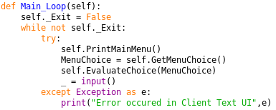
Should an exception be raised I.e a broken connection the exception will be caught in the try-except statement and the program will then continue after alerting the user.

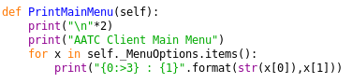
PrintMainMenu prints each command in the MenuOptions dictionary. The procedure loops though each pair of items in the dictionary and prints a formatted string for each line, where the number of the command is right aligned.

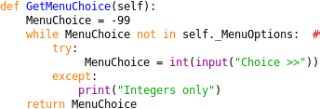
GetMenuChoice obtains an integer result for the option the user would like. The menu choice is set to -99 (will never be a command) and repeatedly loops until the entered number maps to a valid command in the menu options dictionary. For each cycle the user may enter a string, which is either converted into an integer or an exception is raise because it cannot be converted to an integer. This exeption is caught in the try-except statement.

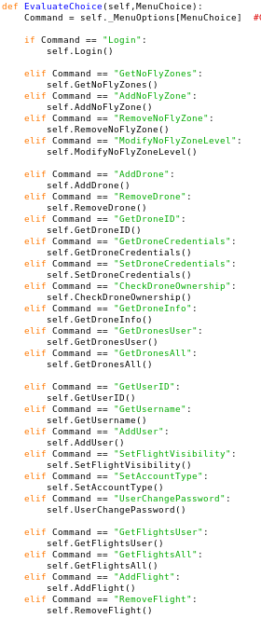
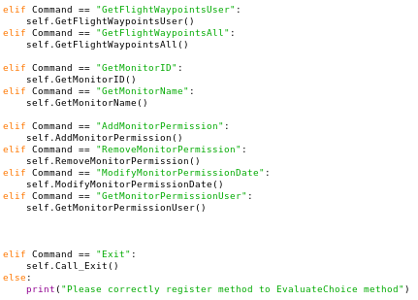

Evaluate choice takes an integer argument , the choice of the user, and executes the relevant instruction. The procedure converts the integer using MenuOptions into a valid command and executes this command using a set of elif statements (probably will be replaced with a dictionary).
Should the command not be in the listed options the program will alert the user of this error and remind them to add the method to the evaluate statement.

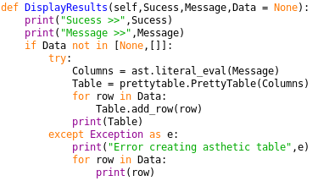
Display results is a method which allows the result of a request to be displayed neatly without having to alter the printing for each function. The method takes two or three arguments, Sucess,Message and Data optionally. The method prints the contents of success and message, then if the data variable is not none or an empty list it attempts to convert the message into a list of column titles using ast.literal_eval, forming a prettytable with these column headings. Then for each row in the data the program adds the row to the table and finally prints the completed table. Should an exception occur while this is happening the program will catch the exception is the try-except statements print a version without the use of ast and pretty table.

Note: The following methods are all very similar and will not be described in detail unless necessary/ a method deviates from the normal. Each method takes zero explicit parameters and does not return anything. The method obtains the required information from the user i.e. login or the drone ID and passes this information to the relevant method of the UserInterface. The result is the passed to the DisplayResults method which displays the information obtained to the user.

Commands
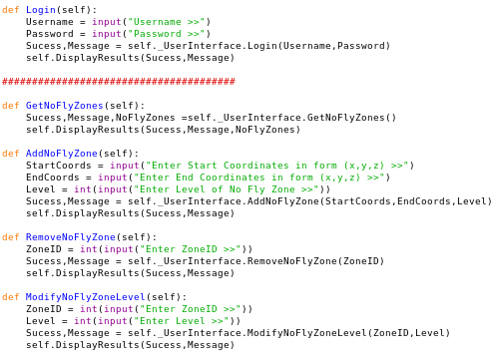
The login method obtains the username and password from the user and passes this information to the relevant function.

The GetNoFlyZones method obtains the no fly zones, no arguments required.

The AddNoFlyZone method obtains the string version of coordinate tuples and the integer level of the no fly zone from the user.

The Remove no fly zone method obtains the integer ID of the no fly zone from the user and passes the information to the relevant function.

The ModifyNoFlyZoneLevel method takes the integer level ID and the ZoneID of the no fly zone which is to be modified and passes the information to the relevant function.

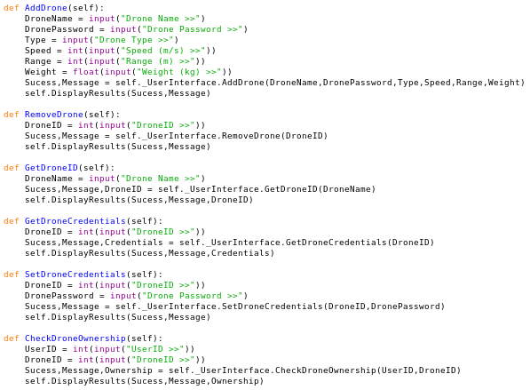
The AddDrone method obtains the string DroneName,DronePassword,Type, the integer Speed and range and the float weight of the drone and passes the information to the relevant function.

The Remove Drone method obtains the integer DroneID and passes the information to the relevant function.

The GetDroneID method obtains a string drone name and passes the information to the relevant function.

The GetDroneCredentials method obtains the intger droneID and passes the information to the relevant function.

The SetDroneCredentials obtains the Integer droneID and the string new password and passes the information to the relevant function.

The CheckDroneOwnership method obtains the integer droneID and UserID and passes the information to the relevant function.

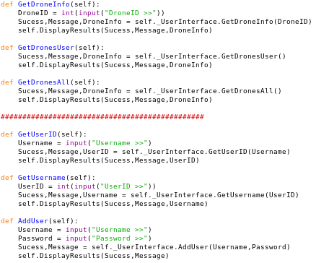
The GetDroneInfo method obtains the integer DroneID and passes the information to the relevant function.

The GetDronesUser method requires no information from the user.

The GetDronesAll method requires no information from the user.

The GetUserID method obtains the string username from the user and passes the information to the relevant function.

The GetUsername method obtains the integer UserID from the user and passes the information to the relevant function.

The AddUser method obtains the string username and password from the user and passes the information to the relevant function.

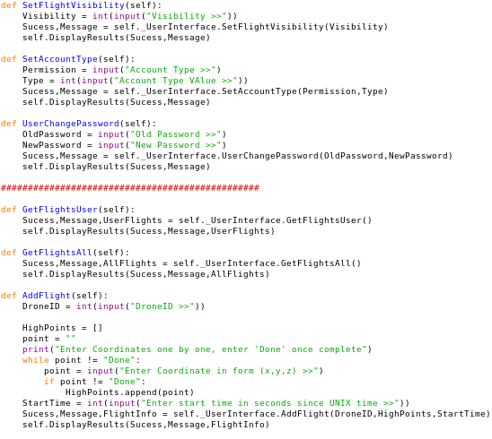
The SetFlightVisibility method obtains the integer visibility value from the user and passes the information to the relevant function.

The SetAccountType method obtains the string permission and integer value from the user and passes the information to the relevant function.

The UserChangePassword method obtains the string old and new passwords and passes the information to the relevant function.

The GetFlightsUser method requires no information from the user.

The GetFlightsAll method requires no information from the user.

The AddFlight method obtains the integer DroneId and start time from the user as well as a list of string tuples containing the coordinates the drone should pass through and passes the information to the relevant function. The method loops through repeatedly until the entered point = “Done” to signify that the user has entered all desired high points ( points between the drone must fly ).

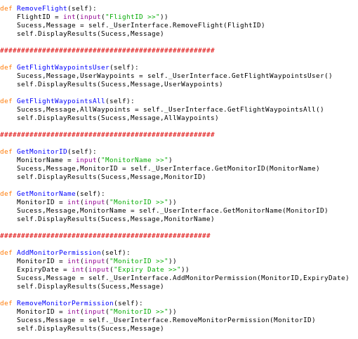
The RemoveFlight method obtains the integer flightID from the user and passes the information to the relevant function.

The GetFlightWaypointsUser method requires no information from the user.

The GetFlightWaypointsAll method requires no information from the user.

The GetMonitorID method requires the string monitor name from the user and passes the information to the relevant function.

The GetMonitorName method obtains the integer MonitorID from the user and passes the information to the relevant function.

The AddMonitorPermission method obtains the integer monitorID and the expiry date from epoch and passes the information to the relevant function.

The RemoveMonitorPermission method obtains the integer monitorID and passes the information to the relevant function.

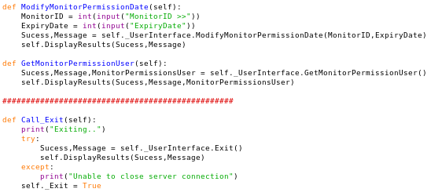
The ModifyMonitorPermissionDate method requires the integer MonitorID and Expiry date from the user and sends this information to the server, displaying a response.

The GetMonitorPermissionUser requires no information from the user.

The Call_Exit method displays that the program may exit and attempts to send the exit command to the server and display the result. If an expection occurs it will be caught in the try-except statement and will warn the user that the connection was not closed sucessfully. Then the self.Exit attribute is set to True so the program may exit the UI main loop.

Main
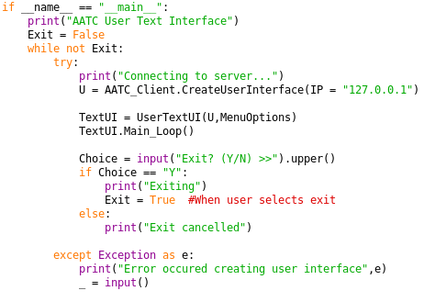
This section starts the program. If the program is the main program the program will enter a while loop until exit = True. In this while loop the program repeatedly creates a connection to the server, passes this information to the __init__ of a UserTextUI object and starts it’s main loop. Once this completes the program asks if the the program should exit completely , if so the program will set Exit = True and exit. Otherwise the exit is cancelled and the loop repeats. Should an exception be raise the try-except statement will catch the exception and alert the user, i.e. the connection could not be established.

